**Assignment 8**

**Name – SURAJ KUMAR YADAV**

**ROLL NO. – 20220PHY014**

1. **Design a 3 – bit Asynchronous Down Counter**

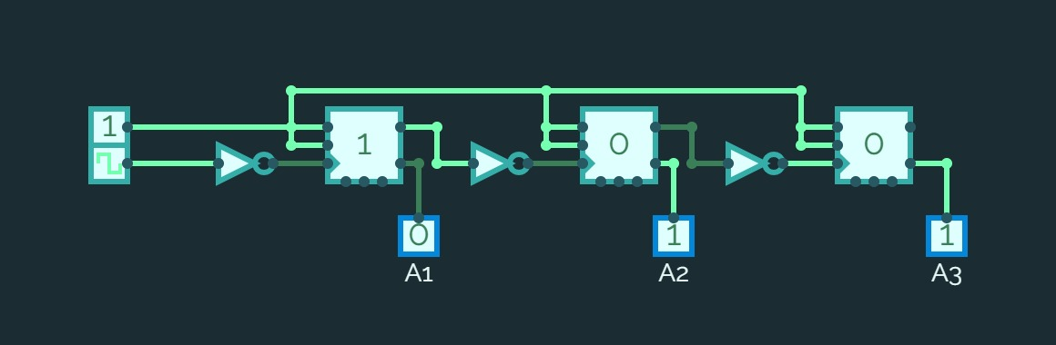

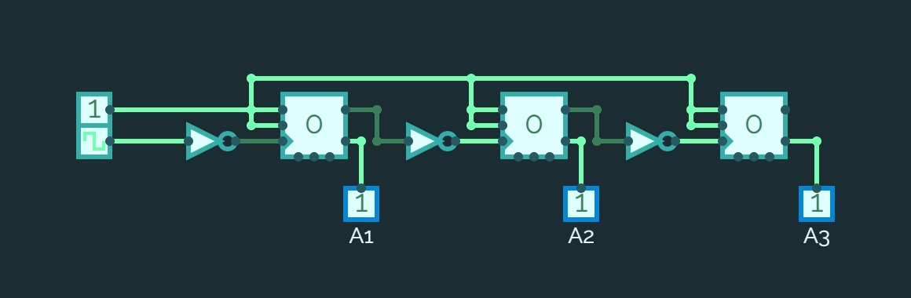

1. **Design a BCD Ripple Counter**

